**ANN Regression**

**Due: 7th Nov**

In this assignment, you’ll use an Artificial Neural Network (ANN) to predict the "PE" (Power Output) of a Combined Cycle Power Plant using four input features from the dataset. This exercise provides hands-on experience in building and tuning an ANN model to understand patterns in energy production data. Below are the feature explanations:

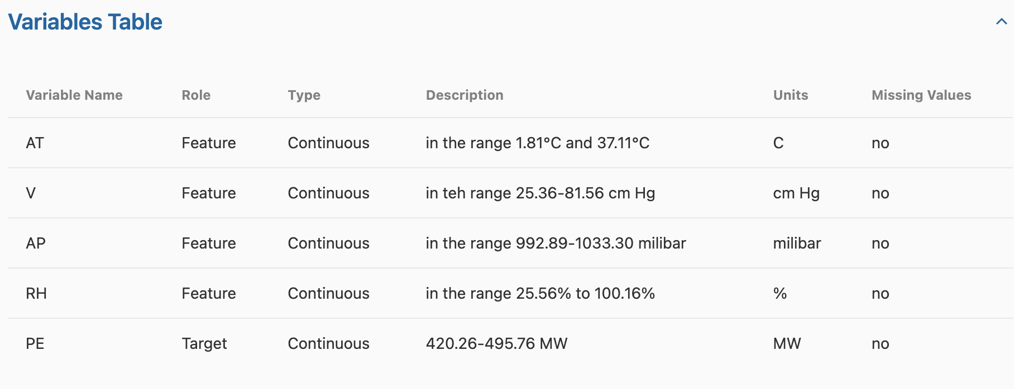

**Preprocessing:**

1. Import the libraries and dataset (use tensorflow for Neural Network)
2. (Optional) Preprocessing steps you think is necessary
3. Train test split

**Building model:**

1. Initialize the ANN
2. Adding **two** dense layer (activation function = relu, and units = 6)
3. Adding a output layer

**Training model:**

1. Compile the ANN (opttimizer = adam, loss = MSE)
2. Training ANN (batchsize = 32, epochs = 100)
3. Predict the test set with your ANN

**Evaluation:**

1. Report the RMSE and R2 with your model
2. If your results are not as expected, don’t worry too much. Instead, provide a brief report discussing potential factors that may have contributed to the outcomes.
3. If your results are good, simply write a two sentence summary